What is BIM? A Beginner's Guide to Building Information Modeling in 2026

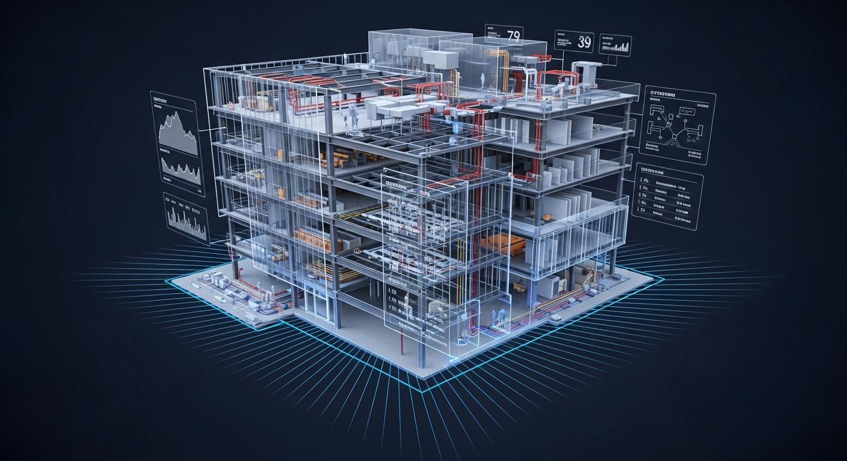
The construction industry is becoming more digital than ever before, and one term you'll hear constantly is BIM. Whether you're a civil engineering student, architect, or someone exploring a career in construction, understanding BIM is one of the best places to start.
In simple words, Building Information Modeling (BIM) is a smarter way to design, build, and manage buildings using intelligent 3D models. It's no longer just a trend—it's becoming a standard workflow for modern construction projects across India and around the world.

What is BIM?
Building Information Modeling (BIM) is the process of creating and managing a digital representation of a building or infrastructure project. It combines a 3D model with real project information such as materials, dimensions, costs, schedules, and maintenance data.

Think of BIM as a digital version of a real building that everyone involved in the project can work on together.
Instead of using separate drawings for different teams, BIM keeps everything connected in one intelligent model.
In one sentence
BIM is a shared 3D digital model that helps architects, engineers, and construction teams collaborate throughout a project's lifecycle.

Why is BIM Important?
BIM helps construction teams work faster, smarter, and with fewer mistakes.
Here's why BIM matters:
- Better collaboration between architects, engineers, and contractors.
- Early detection of design clashes before construction starts.
- Accurate quantity estimation and cost planning.
- Faster project execution with fewer delays.
- Better maintenance and facility management after construction.
As construction projects become larger and more complex, BIM helps every team stay on the same page.

BIM vs Traditional CAD
Many beginners think BIM and AutoCAD are the same. They're not.
Traditional CAD | Building Information Modeling (BIM)
Creates 2D drawings. | Creates intelligent 3D building models.
Lines and shapes only. | Building elements contain real information.
Manual updates across drawings. | Automatic updates across connected models.
Limited collaboration. | Multiple teams work on one shared model.
Simply put: AutoCAD helps you draw a building. BIM helps you build and manage it.

A BIM project follows a connected workflow where every stage shares information.
Project Stage | How BIM Helps
Planning | Visualizes concepts before construction begins.
Design | Creates architectural, structural, and MEP models.
Coordination | Detects clashes between different disciplines.
Construction | Supports scheduling, quantities, and execution.
Operation | Stores building information for maintenance and future renovations.
This connected workflow is what makes BIM different from traditional design methods.

Understanding 3D, 4D and 5D BIM
BIM is more than just a 3D model.
BIM Type | What It Includes
3D BIM | Building geometry and intelligent building components.
4D BIM | Construction schedule and project timeline.
5D BIM | Cost estimation and budgeting.
6D BIM | Facility management and operations.
7D BIM | Sustainability and lifecycle performance.
These BIM dimensions help construction companies plan projects more efficiently from start to finish.

Most Popular BIM Software
Software | Used For
Autodesk Revit | Architectural, structural, and MEP modeling.
Navisworks | Clash detection and project coordination.
Civil 3D | Roads, highways, drainage, and infrastructure design.
Autodesk Construction Cloud | Cloud collaboration and project management.
For most civil engineering students, Revit is the first BIM software to learn because it's widely used across the construction industry.

Who Uses BIM?
BIM is used across almost every discipline in construction.
Professionals who work with BIM include:
- Civil Engineers
- Architects
- Structural Engineers
- MEP Engineers
- Quantity Surveyors
- Project Managers
- Contractors
- Facility Managers
Because BIM connects every department, it's becoming an essential skill across the Architecture, Engineering, and Construction (AEC) industry.

What Does a BIM Engineer Do?
A BIM Engineer creates, manages, and coordinates digital building models for construction projects.
Typical responsibilities include:
- Creating 3D BIM models.
- Coordinating architectural, structural, and MEP models.
- Performing clash detection.
- Preparing construction drawings.
- Extracting quantities from BIM models.
- Supporting project coordination during construction.
BIM Engineers are hired by real estate developers, infrastructure companies, EPC firms, and international engineering consultancies.

Why Should Civil Engineering Students Learn BIM?
If you're pursuing or have completed B.Tech Civil Engineering, BIM is one of the most valuable technical skills you can add to your resume.
Learning BIM helps you:
- Become industry-ready.
- Learn modern construction workflows.
- Improve job opportunities in India and abroad.
- Work with globally used construction software.
- Build practical skills beyond traditional CAD drafting.
As more companies adopt BIM workflows, graduates with BIM knowledge have access to a wider range of career opportunities.

How to Start Learning BIM
If you're a complete beginner, follow this roadmap.
- Understand BIM concepts and terminology.
- Learn Autodesk Revit basics.
- Practice creating architectural and structural models.
- Learn Navisworks for coordination and clash detection.
- Build complete BIM projects for your portfolio.
A practical, project-based approach is the fastest way to learn BIM.

Frequently Asked Questions
Is BIM difficult to learn?
No. BIM is beginner-friendly when learned step by step with practical projects and software training.
Is BIM better than AutoCAD?
BIM offers intelligent 3D collaboration and information management, while AutoCAD is mainly used for drafting and drawing production.
Which BIM software should beginners learn first?
Autodesk Revit is the most recommended starting point for beginners entering the BIM industry.
Is BIM only for architects?
No. BIM is widely used by civil engineers, structural engineers, MEP engineers, contractors, and project managers.
Can I learn BIM after B.Tech Civil Engineering?
Yes. BIM is one of the most recommended career skills for civil engineering graduates entering the construction industry.

Why Learn BIM with Nextudy Education?
Building Information Modeling is more than learning software—it's about understanding how modern construction projects are designed, coordinated, and delivered.
Nextudy Education is among the top BIM training institutes in India, helping civil engineering students and construction professionals build practical BIM skills through industry-oriented training, mentorship, live project exposure, and career guidance.
Whether you're starting your career or upgrading your technical skills, learning BIM can help prepare you for opportunities in real estate, infrastructure, EPC, and international construction projects.
Final Thoughts
BIM is transforming the way buildings are planned, designed, and constructed. Instead of working with disconnected drawings, construction teams now collaborate through intelligent digital models that improve accuracy, reduce errors, and make projects more efficient.
For beginners, understanding BIM is the first step toward a career in digital construction. As BIM adoption continues to grow across India and globally, learning this skill today can open doors to some of the fastest-growing roles in the construction industry.

